Brief summary

The model-CCATT BRAMS predicts less dispersion of aerosols at higher levels (around 3000m) towards Sao Paulo compared to yesterday, but also expected an increase in cloudiness complicating the measures. From CPTEC model’s last running, the position of a center of post-frontal high pressure for tomorrow indicates clear sky to the region of Buenos Aires but in the last few days hotspots in this region have been detected by satellites. During Sept. 12 were still detected an increase in the number of fires in the region of Medellin and Sao Paulo.

Site | Detection Probability
Buenos Aires, Argentina | Low/medium possibility – local smoke aerosol
Bariloche, Argentina | Low possibility – local smoke aerosol (cloud cover)
La Paz, Bolivia | High possibility – local and advected smoke aerosol
São Paulo, Brazil | Medium possibility of transported aerosol (cloud cover)
Manaus, Brazil | High possibility – local smoke aerosol
Concepcion, Chile | Low possibility – local smoke aerosol (cloud cover)
Medellín, Colombia | Medium possibility – local or advected smoke aerosol

Biomass Burning hotspots between 09/11 and 09/12 and smoke area from CCATT-BRAMS model (CPTEC-INPE)

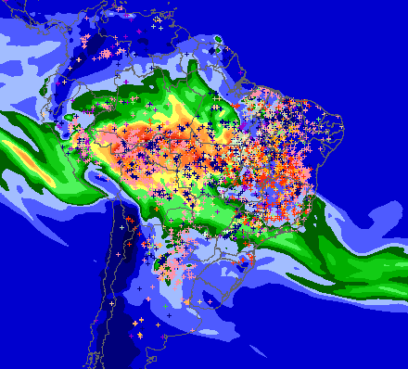
The colors represents Carbon monoxide (ppb)
MP25 from CCATT-BRAMS for 09/13 at 40m

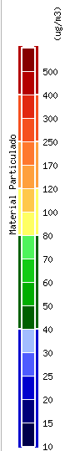 | 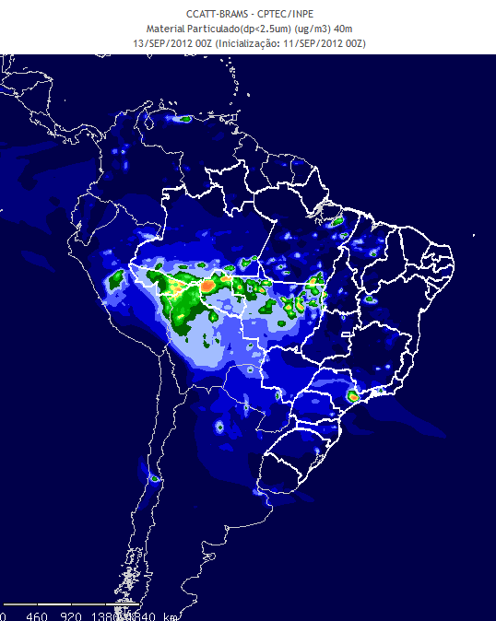 | 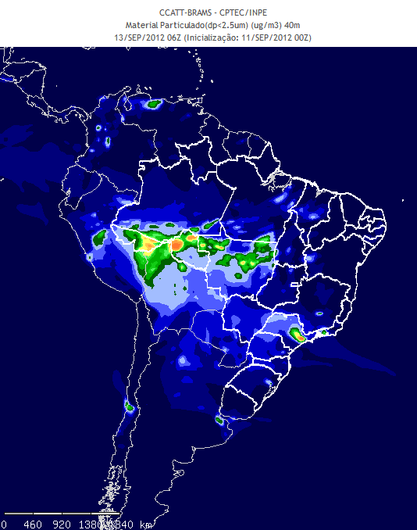
 | 00h | 06h
 | 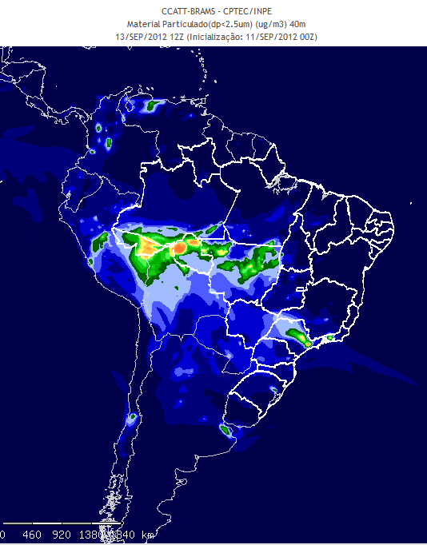 | 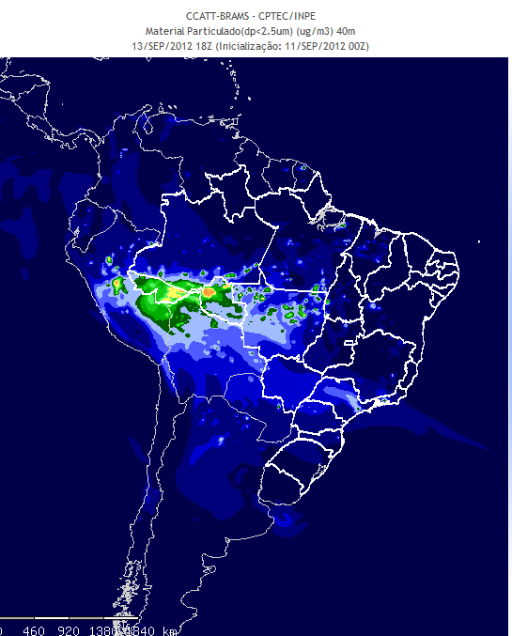
 | 12h | 18h

MP25 from CCATT-BRAMS for 09/13 at 3300m

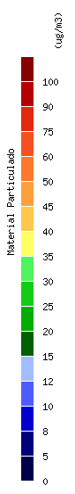 | 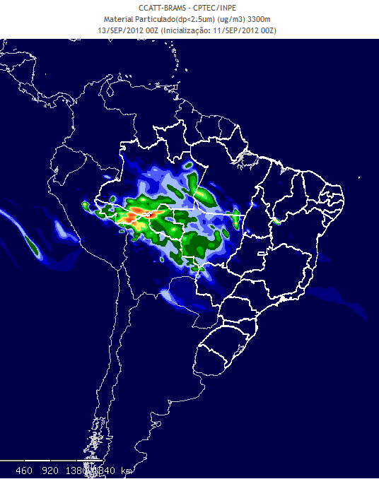 | 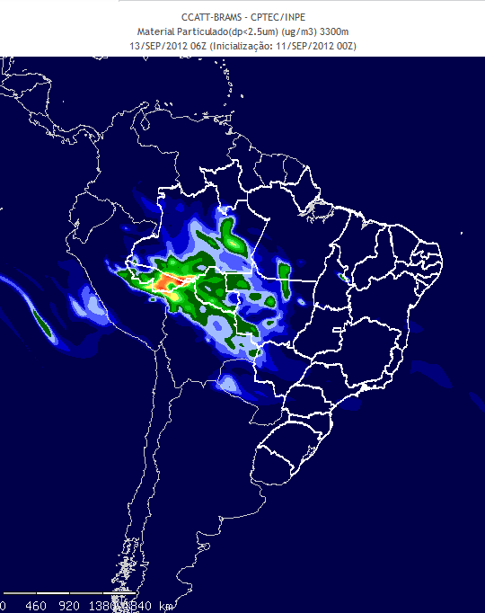
 | 00h | 06h
 | 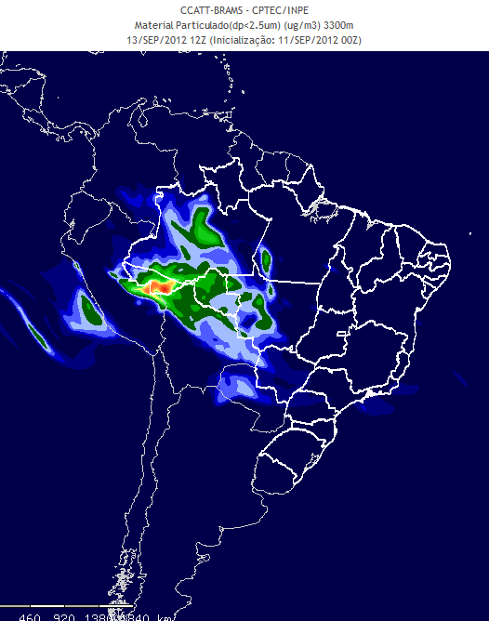 | 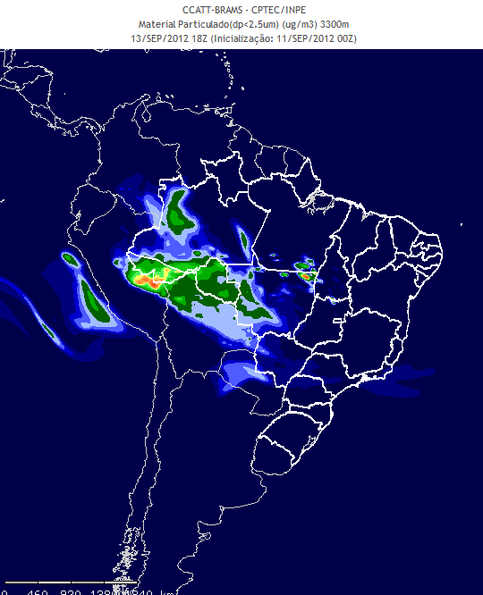
 | 12h | 18h

